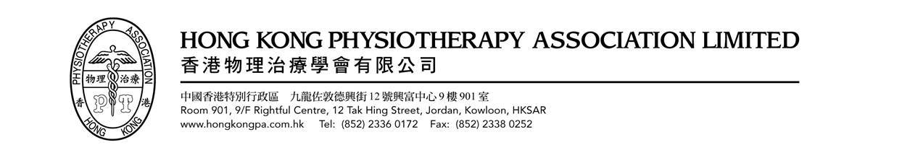
Musculoskeletal Specialty Group

Screening Mechanical vs Non-mechanical Pain
in a Routine Physical Examination

Date : | 13th Aug 2021 (Fri)
Time : | 6:30 – 8:30pm
Speaker : | Ms Rainbow Law & Mr Billy Cheung
Mode : | Online lecture via ZOOM
Capacity : | 100
Deadline : | 30th Jul 2021 (Fri)
CPD Points : | 2 points
Enquiry : | Ms Chiang Lan Fong  Office - 64601217; email – chialf@ha.org.hk
Registration
Full Name : |  | Institution :
HKPA / MPTA Member | Membership No.: | E-mail :
Mailing Address :

Registration Fee (please as appropriate)
HKPA Member (Life / Full / Student) or MPTA* Member |  | Free
Non HKPA Member |  | HK$ 500
*Macau Physical Therapy Association

For application, please complete the registration form and send to “hkpamsg@gmail.com”

For cheque payment, it should be crossed and made payable to “Hong Kong Physiotherapy Association Limited” (Please write your name, contact phone number & course name at the back of the cheque)

Cheque No.: _________________________ Bank: _________________________________

Completed registration form and payment should be sent to:

Ms Chiang Lan Fong
Physiotherapy Department,
Pamela Youde Nethersole Eastern Hospital
3 Lok Man Road, Chai Wan, Hong Kong
Remarks:
- Priority will be given to MSG & HKPA members
- HKPA membership application takes 4-6 weeks to process
- Successful applicants will be notified via email for details of ZOOM connection to lecture
- Presentation in Cantonese/English

Legal Claim Waiver Consent

In consideration of HKPA Ltd. Accepting my registration to this course, I hereby agree to waive all my claim (however accrued) against HKPA Ltd.

Signature :__________________
Name of Registrant :__________________
Date :__________________

*Please sign the above consent when submitting your registration.

Special Weather Arrangement

When Tropical Cyclone Warning Signal No. 8 (or a higher number) and/or Black Rainstorm Signal is hoisted, the following arrangements will apply:

For classes &amp; examinations have not yet started
- If Typhoon Signal No.8 and/or Black Rainstorm Signal is in force 2 hours before the course, the course will be cancelled.

For classes &amp; examinations that have already started
- When Typhoon Signal No.8 or above is hoisted - Classes immediately suspend.

Fee paid are not refundable regardless of whether applicants have attended classes or not, unless the enrolled course is full or in exceptional circumstance deemed acceptable by HKPA.

Objectives of talk:
- Minimize unnecessary complaint by increasing physiotherapists’ sensitivity in picking up subtle s/s during a routine clinical examination – no extra time; no extra test
- Refer patient to specialist physiotherapist accordingly so that patients can receive the help they need
- Maintain physiotherapist’s interest in pain management
- Upkeep physiotherapist’s role & reputation in pain management – we can help the “difficult patients”
- A brief introduction on physiotherapist’s role in chronic pain management

Biography of speakers
Ms. Rainbow Law
Ms. Law is the Physiotherapist In-charge of The Hong Kong Sanatorium & Hospital. She obtained her professional qualification of physiotherapist in 1986 at the Hong Kong Polytechnic. Then, she acquired post-graduate qualifications in manipulative therapy, occupational safety and hygiene, and counselling. She obtained the Master degree in Philosophy in 2001. Since then, she has conducted a few clinical researches in low back pain, functional capacity evaluation and occupational safety and health. The research results were published in local (Journal of Orthopaedics, Trauma and Rehabilitation, Hong Kong Physiotherapy Journal) and international journals (Work, Journal of Advanced Nursing, Journal of Applied Ergonomics, Journal of Occupational Rehabilitation and International Journal of Industrial Ergonomics). She was the visiting lecturer in musculoskeletal rehabilitation and pain management in the Hong Kong Polytechnic University and the Chinese University of Hong Kong. She’s currently a member of the OSH & Rehabilitation Specialty group of the Hong Kong Physiotherapy Association. She is also coordinating the OSH issues on behalf of the OSH Committee of the Hong Kong Sanatorium & Hospital. Her clinical interest is in the management of spinal pain and chronic pain patients.

Mr. Billy Cheung
Mr. Cheung is the physiotherapist of The Hong Kong Sanatorium & Hospital. He obtained his Bachelor degree in Physiotherapy in 2003 and Master degree in Manipulative Physiotherapy in 2009 with Dean’s Honour List award from The Hong Kong Polytechnic University. He has conducted a research topic on neck pain and it was published in Manual Therapy. Since then, he acquired post-graduated specialized training in Functional Capacity Evaluation and work injury management in Canada and USA. Billy has extensive clinical experiences in both inpatient and outpatient settings with particular interest in managing patients with work-injury, chronic pain and vestibular problems.

